**Abstract Factory Design Pattern:** The Abstract Factory Method Design Pattern in Java is used when you need to create a series of related or dependent objects. It is a step above the Factory Method Pattern, providing an interface for creating families of related objects. This pattern involves creating a factory class that can produce multiple types of objects, without the client code having to know the specific classes that are being instantiated.

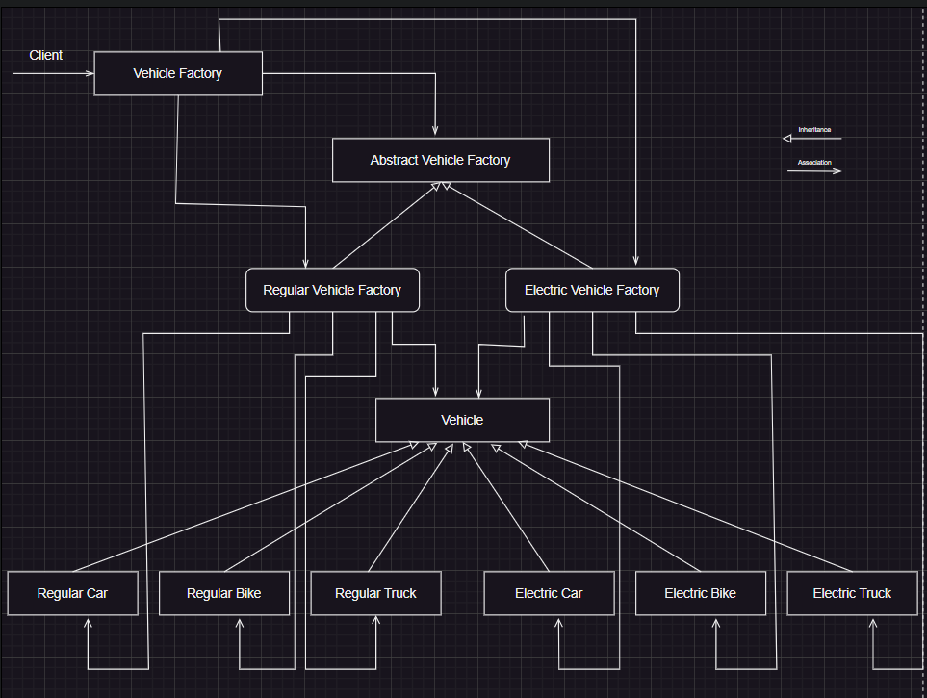

[**Abstract Factory Design Pattern Benefits**](https://www.digitalocean.com/community/tutorials/abstract-factory-design-pattern-in-java#abstract-factory-design-pattern-benefits)

* Abstract Factory design pattern provides approach to code for interface rather than implementation.
* Abstract Factory pattern is “factory of factories” and can be easily extended to accommodate more products, for example we can add another sub-class Hydrogen specific and a factory Hydrogen Vehicle Factory.
* Abstract Factory pattern is robust and avoid conditional logic of Factory pattern.